

Usability Study
Thunderbird
Preferences View

11th February 2019

A research study by Ura Design
Supported by Open Technology Fund



About

Ura Design

Ura is a digital agency focusing on visual communication solutions tailored for Open Source and Internet Freedom projects. They are dedicated to Usability and Experiences by keeping projects’ unique community consensus model in mind.

Ura was founded in 2016 in Albania to cater to the ever-rising demand for Usability and Design services in Open Source Software.

Thunderbird

Thunderbird is an email and messaging client used by 26 million users worldwide. It is produced by a self-governed team focused on stability, privacy, and freedom. Thunderbird prides itself of creating a communications platform that “makes open standards first-class citizens.”

On the security side, Thunderbird provides enterprise-grade security such as TLS/SSL connections to IMAP and SMTP servers. It also offers native support for S/MIME secure email (digital signing and message encryption using certificates).

Optional security protections also include disabling loading of remote images within messages, enabling only specific media types (sanitizer), and disabling JavaScript.

Table of Contents

Introduction | 3
Methodology | 3
Demographics | 6
Follow-up Questions | 8
Heat map | 9
Findings & Recommendations | 11
Conclusions | 21
Exit Questions / User Impressions | 22
Acknowledgments | 23
Licensing | 24

Introduction

Thunderbird is one of the most popular email clients used by millions of users. It is also one of the most established tools for sending PGP encrypted messages.
Throughout the years, Thunderbird’s User Interface has lacked attention and nowadays users experience difficulty navigating the interface, especially the Preferences / Options view, as also shown in our past Usability Study: https://ura.design/projects/thunderbird

This led to a proposal to redesign the Preferences View and come up with a new interface which we are comparing with the old user interface.

Methodology

We conducted testing to identify stumbling points in both designs. We ran the experiments with ten participants in total, representing a diverse range of people. The group was divided in two parts, five participants tested the current design and five participants tested the new design proposal mockup.

Each participant completed the tasks individually in a quiet room while being observed by a professional who guided the testing sessions, took notes, and interviewed each tester.

We did not set any time limit for task completion since the main purpose of the test is to compare the two designs side by side and see how much time it takes on average to complete the tasks on them. Instead, we set a timer for each participant when they started working on the tasks.

Prerequisites
- Thunderbird installed with the current design enabled
- Prototype of the new design

Before starting the testing sessions, we made sure to explain the importance of usability testing briefly.

“Hi [Name], thank you for participating in this session of usability testing for Thunderbird. Usability testing is a method for improving and measuring the ease-of-use of a software.

We’ll give you the tasks one at a time. We aren’t “testing” you. The test is all about the software. If you have problems with parts of the test, that’s okay; that’s exactly what we are trying to find.

Don’t feel embarrassed if you have problems doing something and please do not feel pressured by time or anything else. If you can’t figure something out, that is perfectly okay and will still provide us with useful information for the test. If you have any questions about the tasks we will try to answer them, but the answers and feedback should come directly from you as much as possible so we will avoid anything that might lead you to a specific choice. Also, we’re going to take notes while you’re doing these tasks. It will help us if you talk out loud when you are doing something, so we can take notes.

Example: If you’re looking for a Print button, just say “I’m looking for a Print button” and move the mouse to wherever you are looking on the screen, so we can see where you’re looking.”

We created seven (7) tasks in total.

In the following table are the tasks that were handed out to each participant.

Task
1. You don’t feel comfortable with the current font choice of Thunderbird, and you would like to change it. Please set a font of your preference and increase the font size.
2. Please check if Thunderbird is up to date.
3. You would like to change Thunderbirds default search engine with another option.
4. You want to make sure to not make any spelling mistakes while writing so you look for a feature of Thunderbird to help you with that.
5. Thunderbird can save passwords for each account, so you don't have to re-enter them when you check for new messages. Please enable this feature so you can use it in the future.
6. You find chat notifications annoying, so you decided to disable sound.
7. Please change the time zone.

Demographics

Ten participants took part in this usability test, representing a diverse group of people from different backgrounds and careers.

We also invited testers who participated in our previous usability test for Thunderbird to see how they would react to the new interface.

Thunderbird Usage | Users
Daily | 2
Occasionally | 3
Never | 5

Age | Users
15-25 | 3
26-35 | 6
36-50 | 1

Gender | Users
Women | 5
Men | 5

Follow-up Questions

We extended the testing time and asked questions about specific tasks that
the tester found more difficult to use. Questions like:

- “What were you thinking while completing this task?”

- “Where did you expect to find this icon/menu?”

- “How would it be easier for you to accomplish this task?”

Analysis

We did five rounds of testing in ten sessions. Five participants tested the “Current design” and five tested the “New design mockup.” We did not set a time limit although the maximum time needed to complete the tasks was ten (10) minutes.

Analyzing the Task completion time chart below, we can observe that the “New design mockup” performed slightly better time-wise. We can also see the breakdown of each and compare them side by side to see the underlying issues.
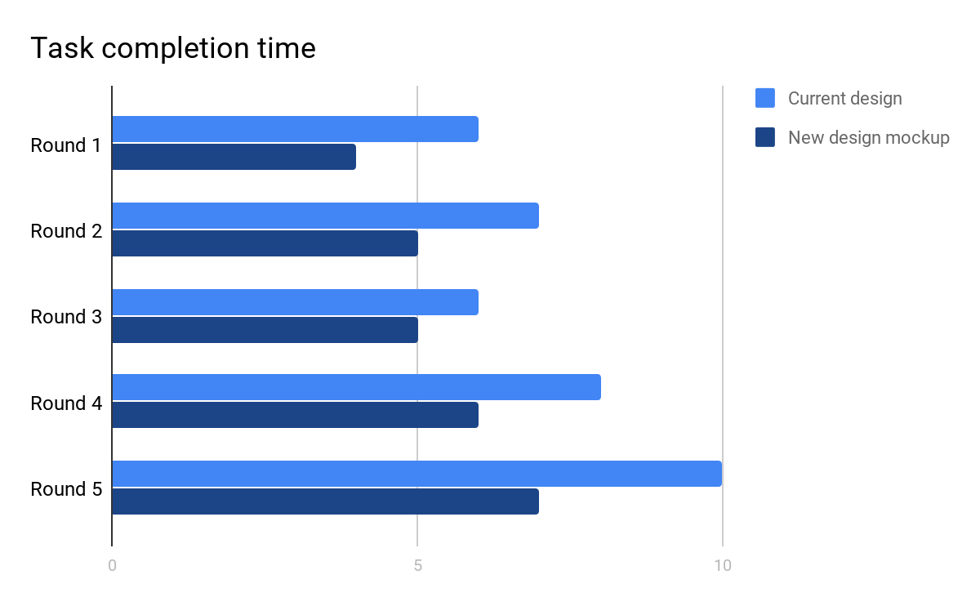
We used a heat map technique to summarize our usability test results. The heat map visualizes how users performed on each task. Below you can find two heat maps, corresponding to each design.
Note: While the current design is in production in Thunderbird, the proposed design is a mockup with limited interaction capabilities, so it is to be expected that if the interface is in production, results will improve compared to the following results which are based on a prototype mockup.

How to read the map:
- Scenario tasks (from the usability test) are arranged in rows
- Test participants are arranged in columns (P1-10)
- The colored blocks represent each tester’s difficulty with each scenario task
G Green blocks represent the ability of the participant to accomplish the tasks with little or no difficulty.

Y Yellow blocks indicate the tasks that the tester had significant difficulties in accomplishing.

R Red blocks indicate that the tester experienced extreme difficulty or completed the tasks incorrectly.

B Black blocks indicate tasks the tester was unable to complete.

Current Design | P  1 | P  2 | P  3 | P  4 | P  5 | P  6 | P  7 | P  8 | P  9 | P  10
1. Change the font and the font size | G | G | G | G | Y | G | G | G | R | Y
2. Check if Thunderbird is updated | Y | R | R | Y | G | Y | R | Y | R | R
3. Change default search engine | G | G | G | Y | Y | G | G | G | G | Y
4. Enable spell check | Y | R | R | Y | G | R | Y | Y | R | R
5. Enable Master Password | Y | Y | Y | Y | G | R | G | G | R | B
6. Disable sound notifications | R | R | Y | G | Y | Y | R | R | B | G
7. Change the time zone | R | Y | Y | G | Y | R | B | G | G | R

New Design | P  1 | P  2 | P  3 | P  4 | P  5 | P  6 | P  7 | P  8 | P  9 | P  10
1. Change the font and the font size | G | G | G | G | Y | G | G | G | G | Y
2. Check if Thunderbird is updated | G | G | Y | G | G | Y | G | Y | G | G
3. Change default search engine | G | G | G | Y | Y | G | G | G | G | Y
4. Enable spell check | Y | R | G | Y | G | G | G | Y | G | Y
5. Enable Master Password | Y | Y | Y | G | G | G | G | G | Y | Y
6. Disable sound notifications | R | R | Y | G | Y | Y | R | R | R | G
7. Change the time zone | R | Y | Y | G | Y | R | B | G | G | R

Tasks (Current Design)

Task #1. Change the font and the font size
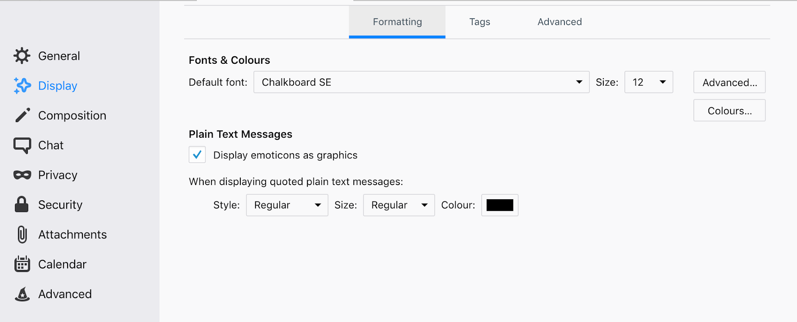
This task performed reasonably well. Changing and adjusting the font is a common task on most applications. Users were already familiar with this process, so finding this option listed on the “Display” menu posed little difficulty in most cases. The fact that the “Formatting” tab is listed first contributed to positive performance on the task since users did not need to go through the other tabs.

Task #2. Check if Thunderbird is updated

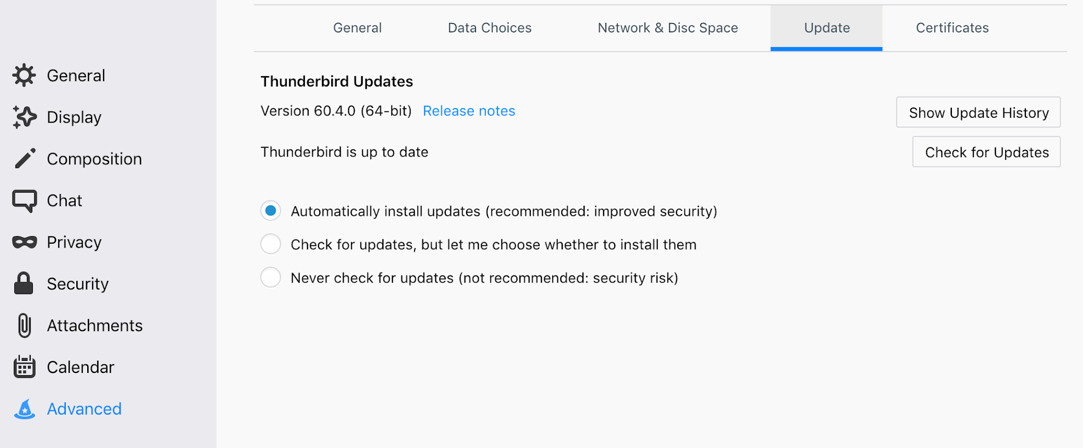

This task was challenging for most users. At first, users did not know where to find this option, so they started exploring the sidebar menus.
The first choice in most cases was “General.” They did not find this option there, so they kept searching randomly under other menus, which resulted in a longer time to finish this task since “Advanced” is the last one listed on the sidebar.

Even when the users clicked “Advanced,” they had difficulty navigating through the horizontal tabs. They only explored the first option “General” and ignored the other tabs “Data Choices,” “Network & Disc Space,” “Update,” “Certificates.”

Task #3. Change Default Search Engine

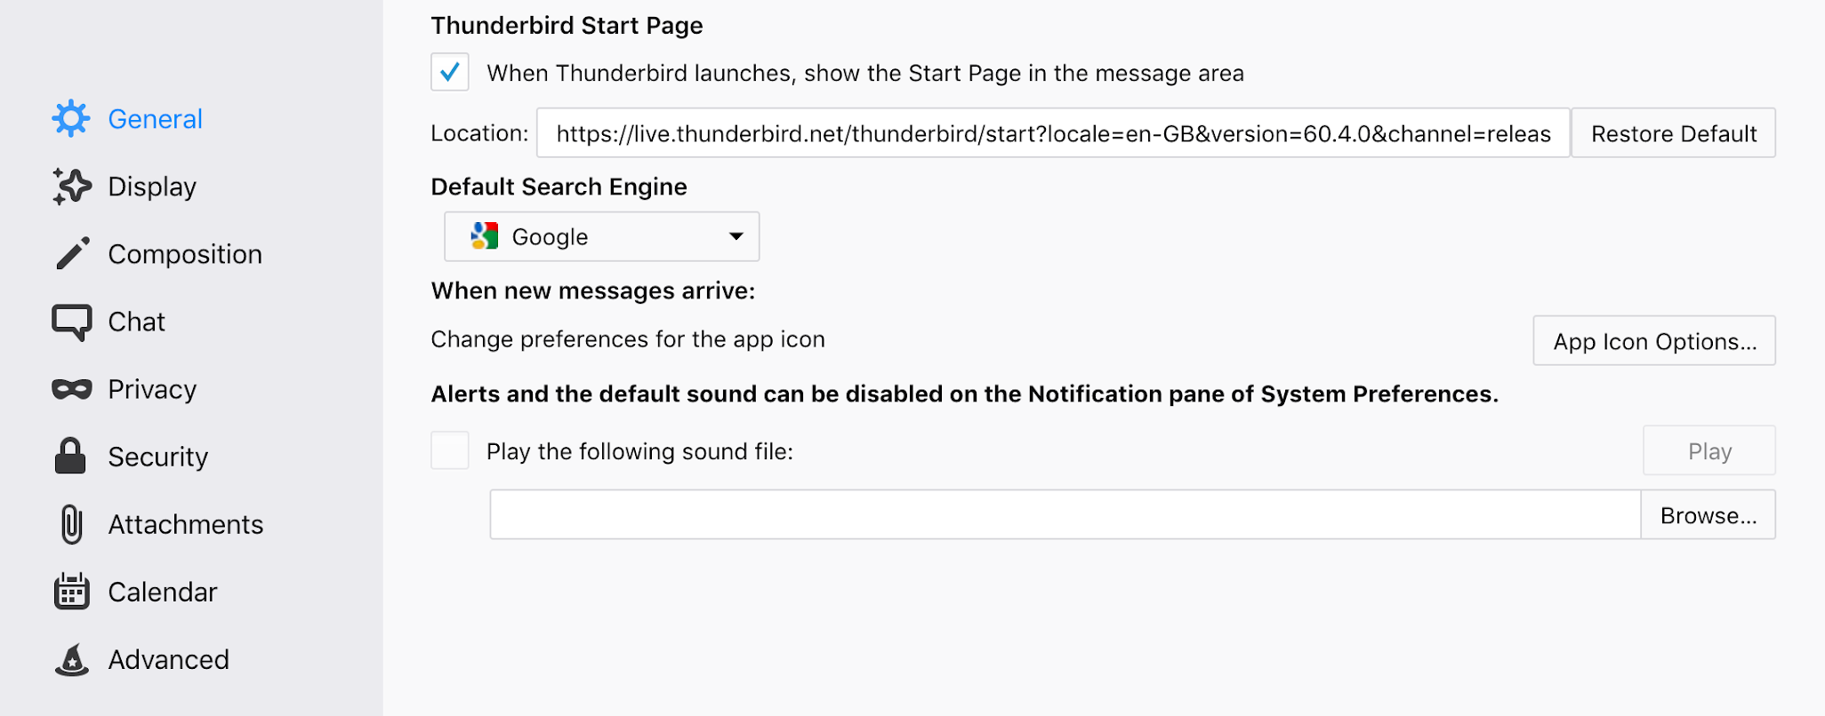

Changing the default search engine was easy to locate since it is the first menu on the sidebar and has no horizontal bar. However, some participants had difficulty understanding the task because they were not familiar with the term “Search Engine.”

Task #4. Enable Spell Check

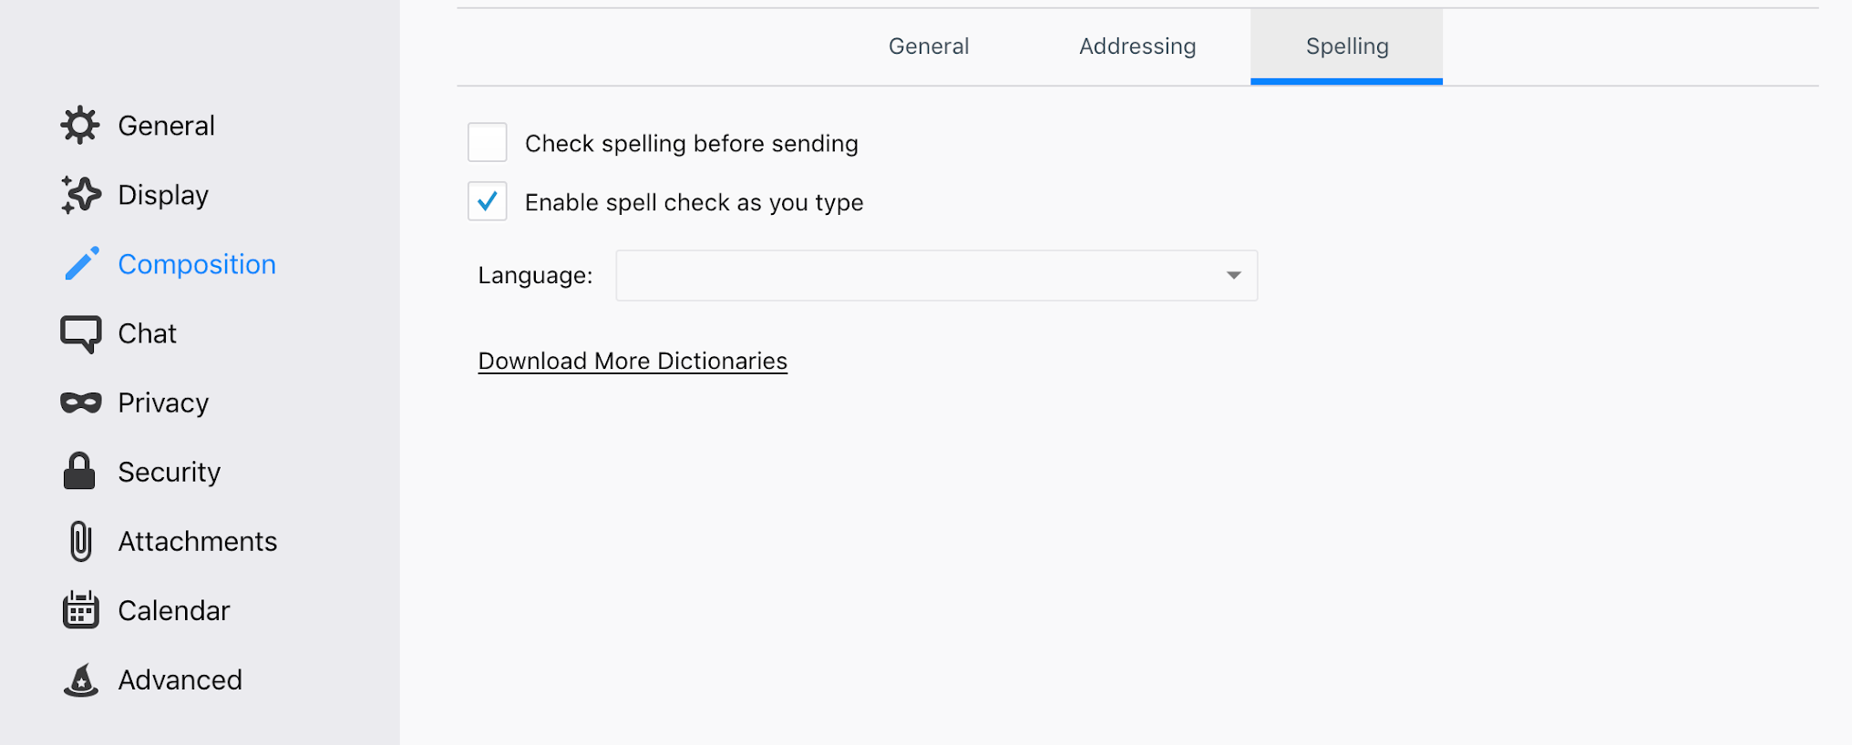

There were three options that testers suspected for accomplishing this task: the “General,” “Composition,” and “Chat” tabs. Similar to the other tasks, even when testers were on the “Composition” screen, they only checked the General tab and skipped “Addressing” or “Spelling.”

Task #5. Enable Master Password

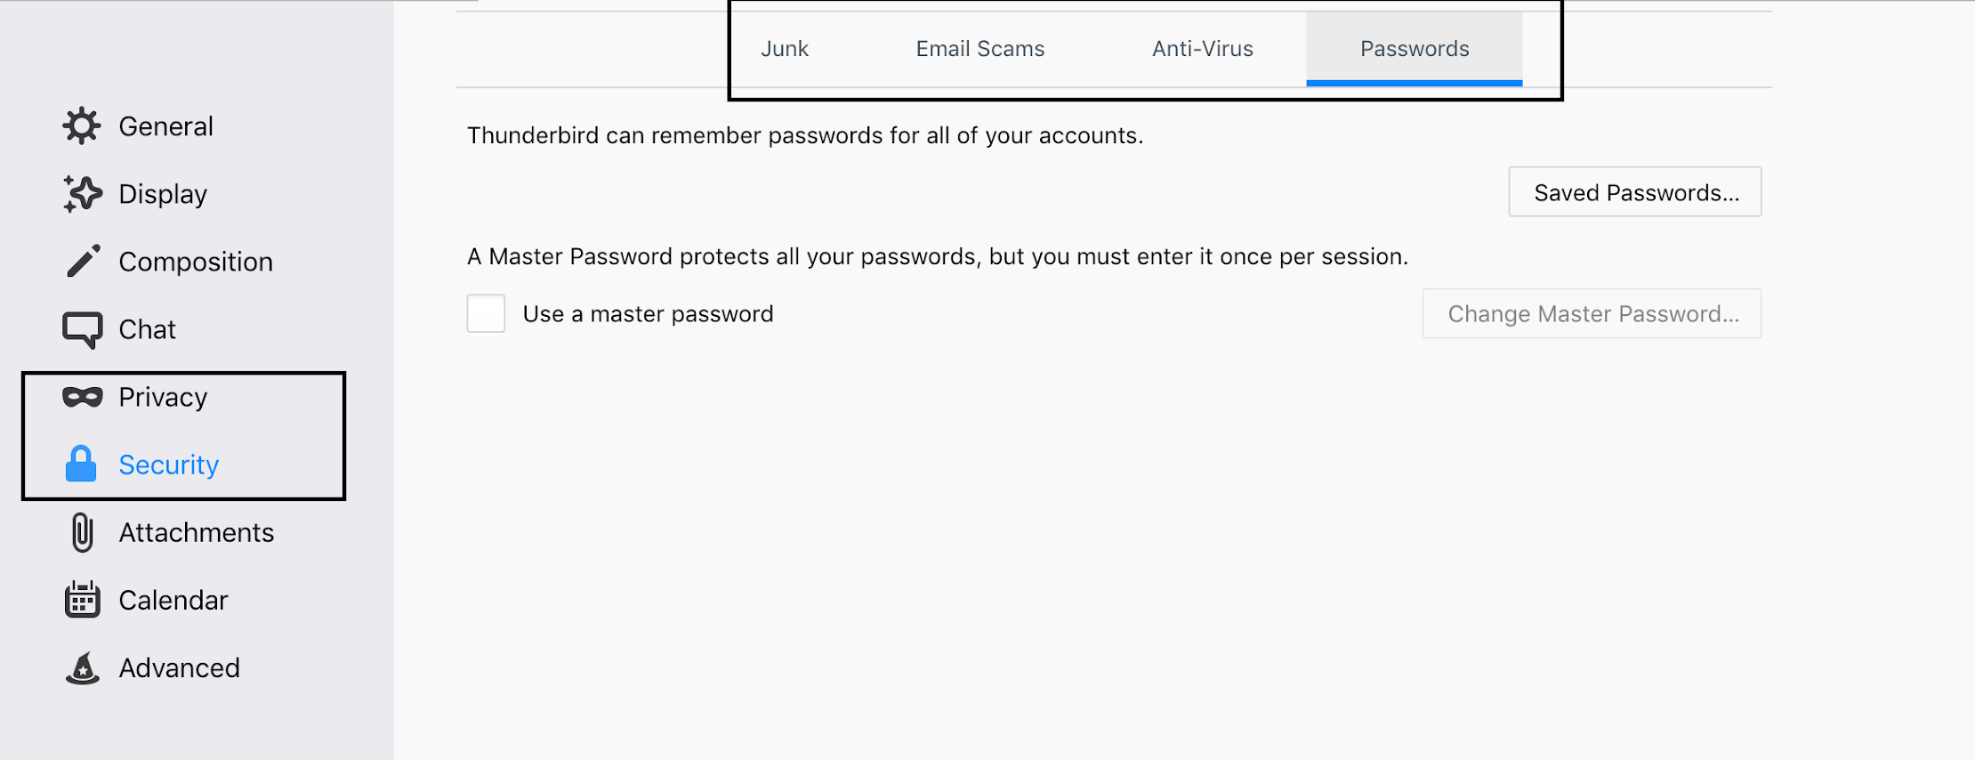

Even users who were not familiar with the term “Master password” and its function immediately knew that there were two options on the menu where they would find it, either “Privacy” or “Security” because “Password” should be something related to one of them; however, they were not sure which so they tried both. Once again, we had the same issue of users ignoring the horizontal tabs.
Task #6. Disable sound notifications

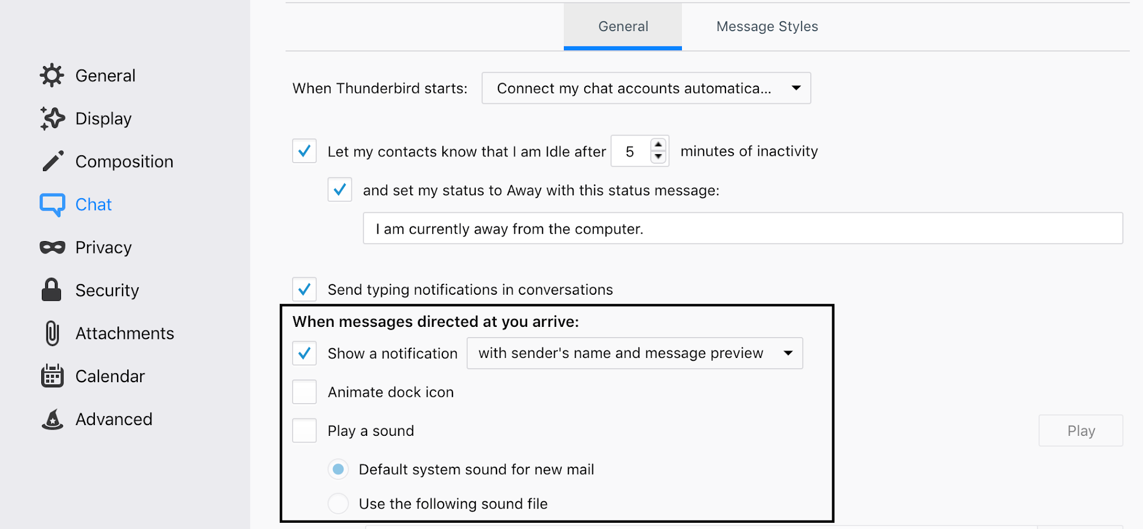

Participants had mixed thoughts on whether this would be placed under “Composition” or “Chat” so they tried both. Even once they had navigated to the “Chat” menu, they found it difficult to notice the notification option. They described the Chat → General screen as having “too much text.”

Task #7. Change the time zone

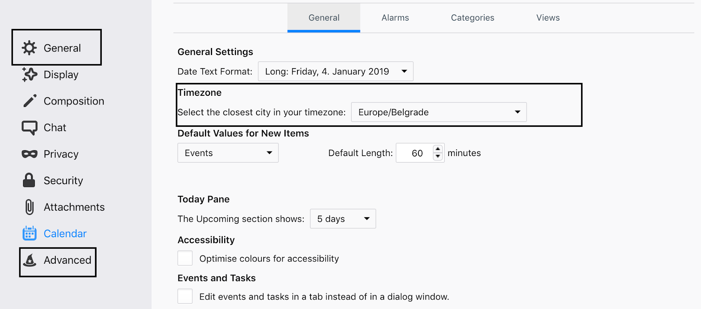

Although this option is located on “Calendar,” all participants suspected it to be on “General” or “Advanced” because they thought this was an option that applied to the whole app and not just the calendar.

Tasks (Proposed New Design)

We repeated the same tasks but this time with the new proposed design.

Task #1. Change the font and the font size

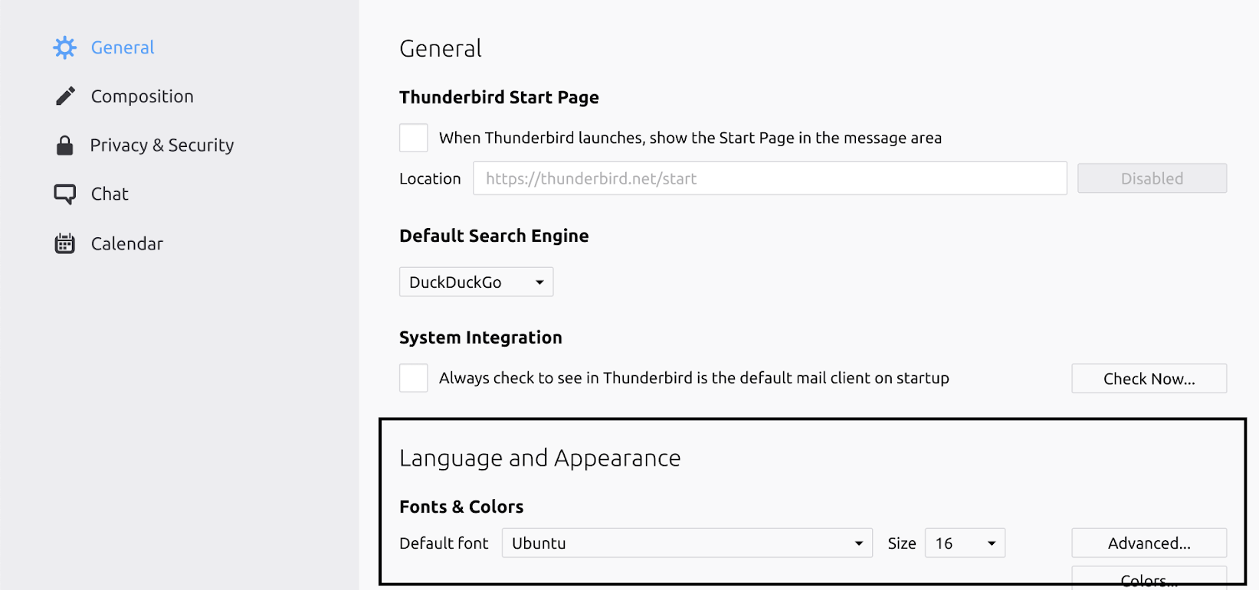

As we can notice from the heat map, we did not have any issues with adjusting fonts. They were placed exactly where users expected, and “Language and Appearance” are placed at the beginning which made it easier to find.

Task #2. Check if Thunderbird is updated

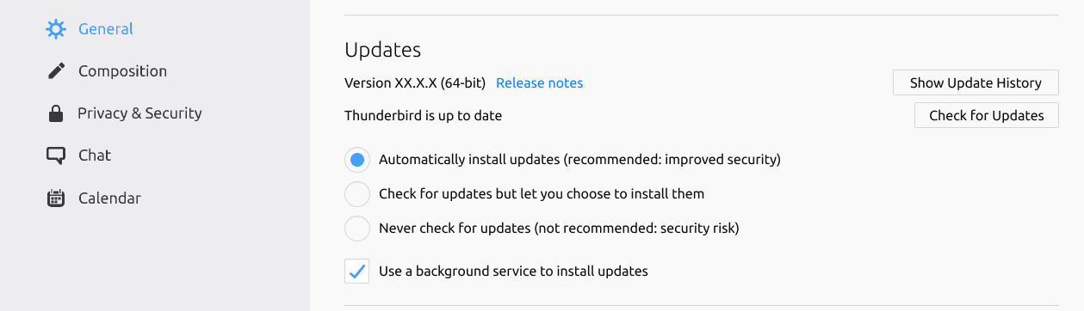

Again the task performed well. Similar to the first task, they found the “Updates” section immediately since it was placed at the beginning.
Task #3. Change default search engine

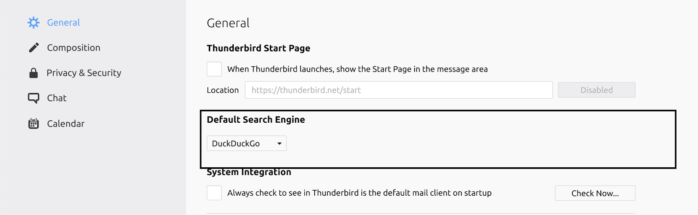

Again, the users did not encounter any issues with this task. Change default search engine is placed at the beginning, which makes it easily accessible even to users who are not familiar with the term “Default search engine.”

Task #4. Enable spell check

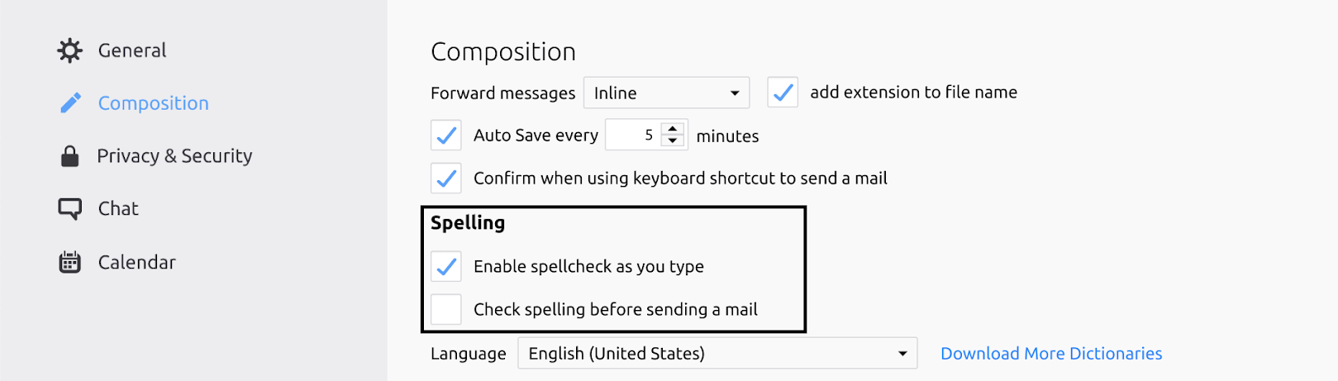

Similar to the “Current Design,” testers were slightly confused and were unsure where to find this option on “Chat” or “Composition.” On the other hand, they did not have the horizontal tabs issue that participants who tested the “Current design” encountered. Once they clicked “Composition,” the spelling option showed immediately.

Task #5. Enable Master Password

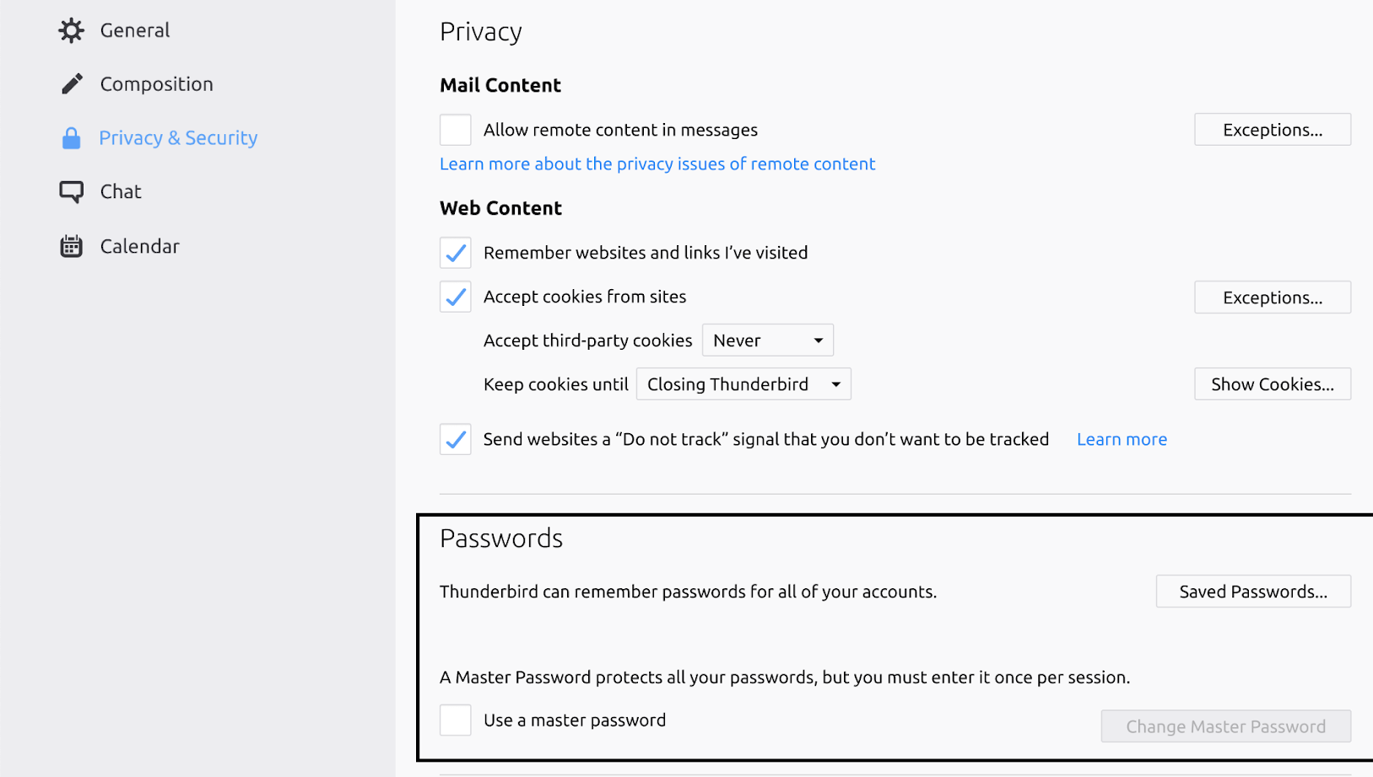

If we compare this task on both heat maps, we can see that this one is the most improved one. First, none of the participants had trouble deciding whether they should click “Privacy” or “Security” since they are merged together in this version. The “Passwords” section is placed at the beginning, which makes it easy to notice.

Task #6. Disable Sound Notifications

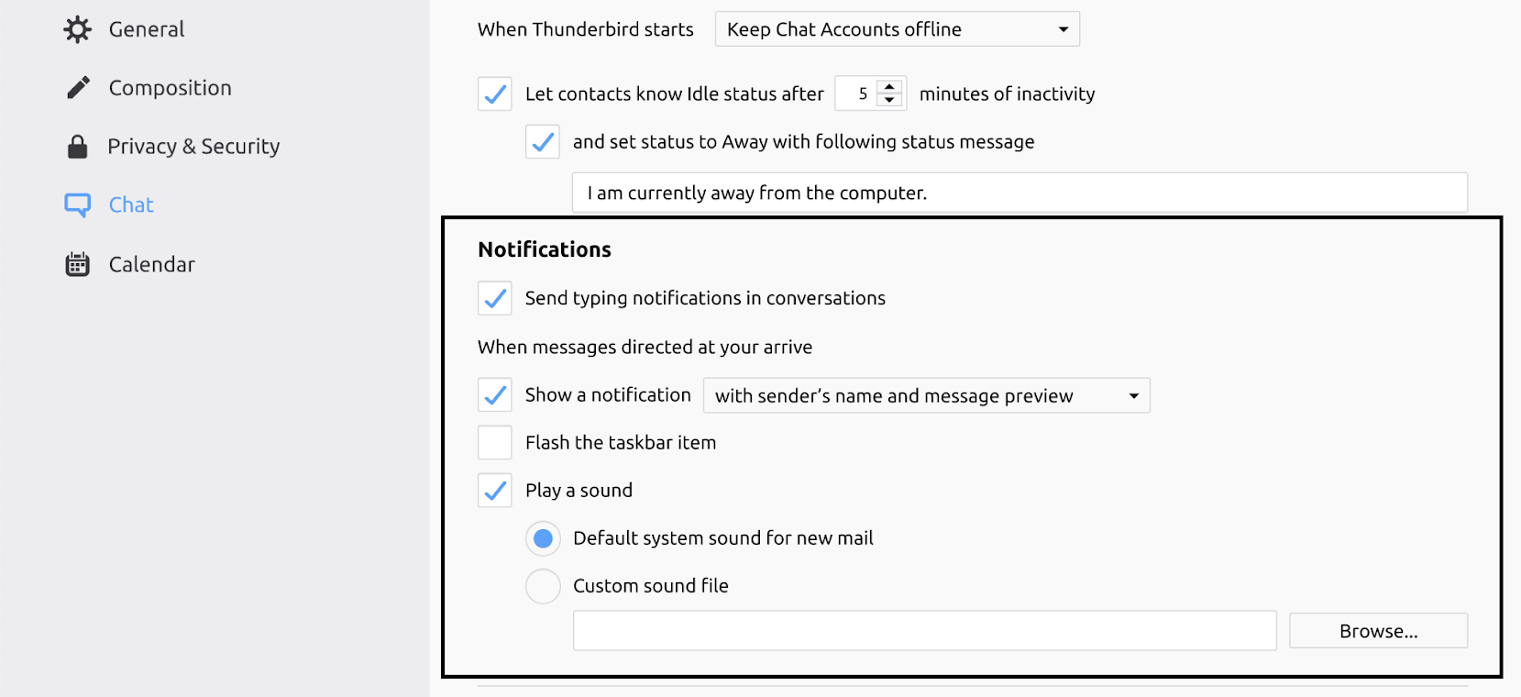

The “Chat” and “Composition” mix up issue continued here. Also, users found the “Chat” screen intimidating because of the amount of text.

Task #7. Change the time zone

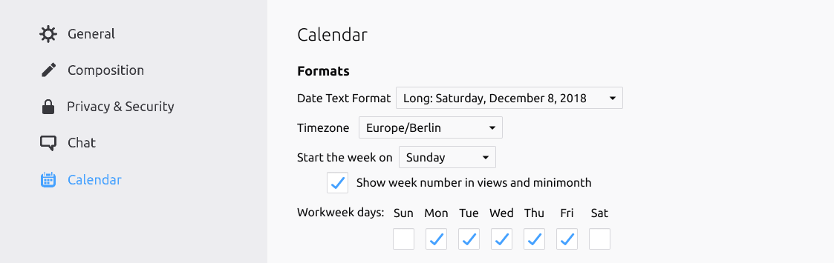

This task was trickier for most testers. They expected this option to be listed on the “General” menu.

Conclusion

Comparing the two designs side by side gave us perspective from a timing angle and a usability angle. While there is always room for improvements, we can now see some common patterns and have a clearer idea on what needs to be improved.

There were two main differences on these designs that shifted users’ focus:
- The information infrastructure/layout
- The sidebar

The current design has a more spread-out approach in the way it organizes the information, with horizontal tabs and more sidebar options, which results in a “cleaner feel” of the app in general and makes it more aesthetically pleasing on the first sight (more white space), but causes much more confusion when searching for any option.

On the other hand, the new design has a well-thought-out and simple approach to the information infrastructure, which increases the usability drastically, but that also leads to design feeling a little “overcrowded.”

Users did not need to think as much about where things are placed on the new design. Since there are only 5 categories, everything made more sense. For example, on the “Set a master password” task in the old design, users had a hard time deciding where that might be placed, either under Privacy or Security because to them these go hand in hand. Testers kept going back and forth between these options to search for where it was placed. Meanwhile, the new design merged and simplified this task for the participants.

Users often confused “General on the sidebar” with “General” on the horizontal bar on the old design, this issue is also eliminated on the new design.

Before starting a task, each participant was asked “Where do you think this option is placed?” or “Where does it make more sense to you to find?” They usually chose options that they thought were related to the task. For example, on the task “Change the font,” they expected it to be under “General” or “Display” and that is where they looked first, but there are some options on the sidebar that did not relate to any task, for example, “Attachments” or “Advanced” that were mostly skipped during this process since users couldn’t relate anything to that.

Acknowledgments

Ura Team Members who worked on this study:

Renata Gegaj Usability Researcher
Anxhelo Lushka Frontend Designer
Elio Qoshi Creative Lead

This research has been made possible by Open Tech Fund, which kindly sponsored this work.

This study has been conducted in Prishtina, Kosova.

Licensing

Some rights reserved © 2019 Ura Design

This work is licensed under a Creative Commons Attribution ShareAlike 4.0 International License.

You can find the full license text here.

First published on 12th February 2019.

